 



Database Programming with SQL 15-2: DML Operations and Views Practice Activities

# Objectives

* Write and execute a query that performs DML operations on a simple view
* Name the conditions that restrict modifying a view using DML operations
* Write and execute a query using the WITH CHECK OPTION clause
* Explain the use of WITH CHECK OPTION as it applies to integrity constraints and data validation
* Apply the WITH READ ONLY option to a view to restrict DML operations

# Vocabulary

Identify the vocabulary word for each definition below.

|  |  |
| --- | --- |
| **ROWNUM** | A pseudocolumn which assigns a sequential value starting with 1 to each of the rows returned from the subquery |
| **WITH CHECK OPTION** | Specifies that INSERTS and UPDATES performed through the view can’t create rows which the view cannot select |
| **WITH READ ONLY** | Ensures that no DML operations can be performed on this view |

# Try It / Solve It

Use the DESCRIBE statement to verify that you have tables named copy_d_songs, copy_d_events, copy_d_cds, and copy_d_clients in your schema. If you don't, write a query to create a copy of each.

CREATE TABLE copy_d_songs

AS ( SELECT * FROM d_songs);

DESCRIBE copy_d_songs;

DESCRIBE d_songs;

SELECT * FROM d_songs;

SELECT * FROM copy_d_songs;

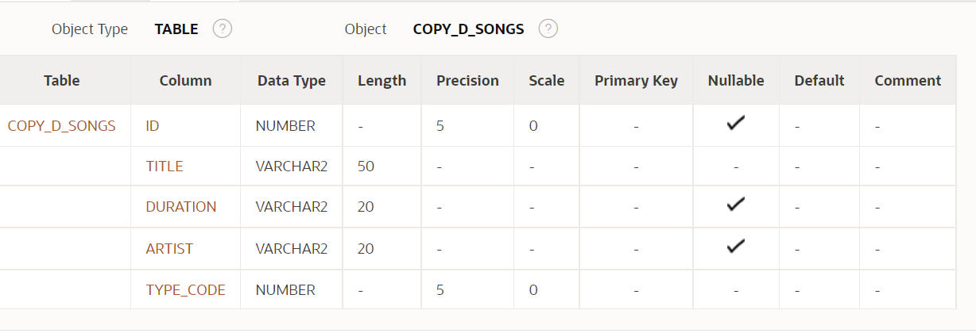

CREATE TABLE copy_d_events

AS ( SELECT * FROM d_events);

DESCRIBE copy_d_events ;

DESCRIBE d_events;

SELECT * FROM d_events ;

SELECT * FROM copy_d_events ;

CREATE TABLE copy_d_cds

AS ( SELECT * FROM d_cds);

DESCRIBE copy_d_cds;

DESCRIBE d_cds;

SELECT * FROM d_cds;

SELECT * FROM copy_d_cds ;

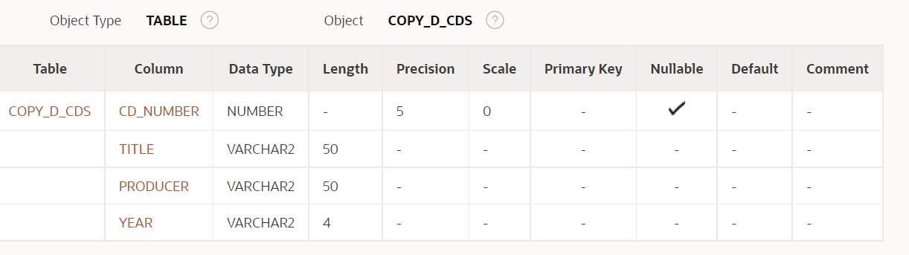

CREATE TABLE copy_d_clients

AS ( SELECT * FROM d_clients);

DESCRIBE copy_d_clients ;

DESCRIBE d_clients;

SELECT * FROM d_clients ;

SELECT * FROM copy_d_clients ;

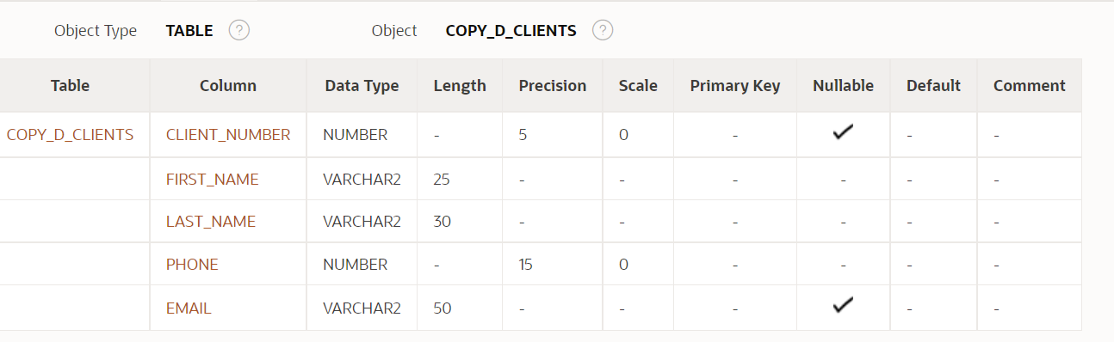

1. Query the data dictionary USER_UPDATABLE_COLUMNS to make sure the columns in the base tables will allow UPDATE, INSERT, or DELETE. Use a SELECT statement. All table names in the data dictionary are stored in uppercase.

USER_UPDATABLE_COLUMNS describes columns in a join view that can be updated by the current user, subject to appropriate privileges.

**SELECT owner, table_name, column_name, updatable,insertable, deletable**

**FROM user_updatable_columns WHERE LOWER(table_name) = 'copy_d_songs';**

**SELECT owner, table_name, column_name, updatable,insertable, deletable**

**FROM user_updatable_columns WHERE LOWER(table_name) = 'copy_d_events';**

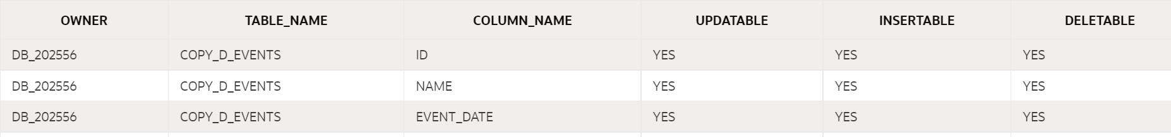

**SELECT owner, table_name, column_name, updatable,insertable, deletable**

**FROM user_updatable_columns WHERE LOWER(table_name) = 'copy_d_cds';**

**SELECT owner, table_name, column_name, updatable,insertable, deletable**

**FROM user_updatable_columns WHERE LOWER(table_name) = 'copy_d_clients';**

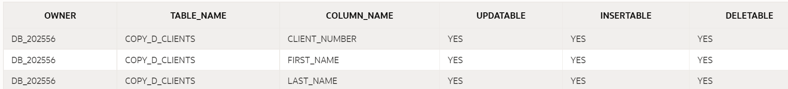

1. Use the CREATE or REPLACE option to create a view of *all* the columns in the copy_d_songs table called view_copy_d_songs.

**CREATE OR REPLACE VIEW view_copy_d_songs  AS**

**SELECT \***

**FROM copy_d_songs;**

**SELECT * FROM view_copy_d_songs;**

1. Use view_copy_d_songs to INSERT the following data into the underlying copy_d_songs table. Execute a SELECT * from copy_d_songs to verify your DML command. See the graphic.

|  |  |  |  |  |
| --- | --- | --- | --- | --- |
| ID | TITLE | DURATION | ARTIST | TYPE_CODE |
| 88 | Mello Jello | 2 | The What | 4 |

**INSERT INTO view_copy_d_songs(id,title,duration,artist,type_code)**

**VALUES(88,'Mello Jello','2 min','The What',4);**



1. Create a view based on the DJs on Demand COPY_D_CDS table. Name the view read_copy_d_cds. Select all columns to be included in the view. Add a WHERE clause to restrict the year to 2000. Add the WITH READ ONLY option.

**CREATE OR REPLACE VIEW read_copy_d_cds  AS**

**SELECT \***

**FROM copy_d_cds**

**WHERE year = '2000'**

**WITH READ ONLY ;**

**SELECT * FROM read_copy_d_cds;**



1. Using the read_copy_d_cds view, execute a DELETE FROM read_copy_d_cds WHERE cd_number = 90;

**ORA-42399: cannot perform a DML operation on a read-only view**

1. Use REPLACE to modify read_copy_d_cds. Replace the READ ONLY option with WITH CHECK OPTION CONSTRAINT ck_read_copy_d_cds. Execute a SELECT * statement to verify that the view exists.



1. Use the read_copy_d_cds view to delete any CD of year 2000 from the underlying copy_d_cds.

**DELETE FROM read_copy_d_cds**

**WHERE year = '2000';**

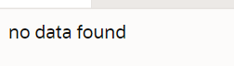

1. Use the read_copy_d_cds view to delete cd_number 90 from the underlying copy_d_cds table.

**DELETE FROM read_copy_d_cds**

**WHERE cd_number = 90;**

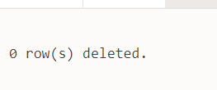

1. Use the read_copy_d_cds view to delete year 2001 records.

**DELETE FROM read_copy_d_cds**

**WHERE year = '2001';**

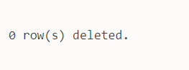

1. Execute a SELECT * statement for the base table copy_d_cds. What rows were deleted?

**Only the one in problem 7 above, not the one in 8 and 9**

1. What are the restrictions on modifying data through a view?

For simple views, all DML’s are OK, but for complex views:

**Delete restricted if it contains:**

Group functions

GROUP BY CLAUSE

DISTINCT

pseudocolumn ROWNUM  Keyword

**Modify restricted if it contains:**

Group functions

GROUP BY CLAUSE

DISTINCT

pseudocolumn ROWNUM Keyword

*Column defined by expressions*

**INSERT restricted if it contains:**

Group functions

GROUP BY CLAUSE

DISTINCT

pseudocolumn ROWNUM Keyword

Column defined by expressions

*Does not include NOT NULL columns in the base table.*

1. What is Moore’s Law? Do you consider that it will continue to apply indefinitely? Support your opinion with research from the internet.

**It roughly predicted that computing power nearly doubles every year. But Moore also said in 2005 that as per nature of exponential functions, this trend may not continue forever.**

1. What is the “singularity” in terms of computing?

**Is the hypothesis that the invention of artificial superintelligence will abruptly trigger runaway technological growth, resulting in unfathomable changes to human civilization.**

**3 Reasons To Believe The Singularity Is Near as per Greg Satell on Forbes:**

•         **We’re Going Beyond Moore’s Law**

•         **Robots Are Doing Human Jobs**

•         **We’re Editing Genes**

Copyright © 2020, Oracle and/or its affiliates. All rights reserved. Oracle and Java are registered trademarks of Oracle and/or its affiliates. Other names may be trademarks of their respective owners.